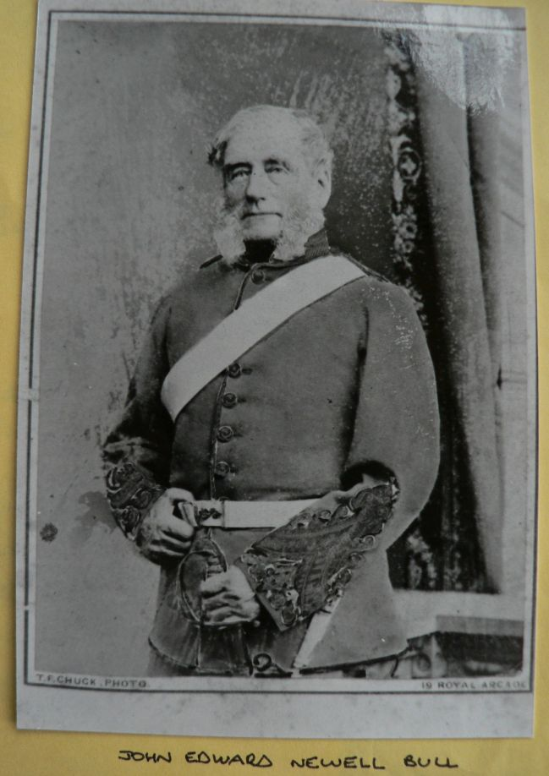

**Colonel John Edward Newell Bull** played a huge part in the development of Castlemaine in general and had a profound impact on the **Castlemaine Rifle Club** who in 2016 held their **Inaugural Colonel Bull Trophy competition**.

I thought I would begin by recounting the story Chris’ partner Glenda Keel wrote about the inaugural event named in Col Bull’s honour and over issues serialise the life story of this brilliant man who was born in Athlone, Roscommon, Ireland and died in Goulburn, N.S.W., Australia aged 94, having spent 44 of those years in Central Victoria.

Glenda’s report is as follows: On Saturday 3rd December 2016, the Castlemaine Rifle Club (C.R.C.) was honoured and proud to host the Inaugural colonel Bull Trophy in the presence of a unique gathering of some of his descendants. Colonel John Edward Newell Bull (1806-1901) was the man who donated land in 1861 to the Volunteer Riflemen which is now the home range of Castlemaine Rifle Club.

Colonel Bull’s father, Captain Robert Bull led the last artillery charge at the Battle of Waterloo and has a section of the London Museum dedicated to him and his men.

Colonel Bull’s great-great Granddaughter Cheryl Looby (pictured below) and her husband Paul discovered this connection to the Castlemaine Rifle Range whilst researching family history, consequently after visiting the Range and meeting members of our Club, they decided to donate a trophy to commemorate Colonel Bull and his family by presenting the Club with a framed Lifeline/Family Tree of Colonel Bull along with a magnificent trophy.

The Inaugural Col. Bull Trophy was implemented into our Club Championship series, held over 12 months with 8 stages over various ranges starting at 300 yds and moving

back to the long range of 900 yds. The day’s shoot was the 4th stage, the half-way mark of our championship and was shot over 500 and 600 yds on the day.

The day was mild, warm with a slight breeze and mirage. Cheryl and Paul Looby also participated, both having their first try at rifle shooting, and both doing creditably well. The speciality and historical significance of this truly incredible occasion was attended by many special guests including a good contingent of Colonel Bull’s descendants, some from Bendigo, Castlemaine and interstate as well. Members from visiting local clubs also attended which created a relaxed friendly atmosphere throughout the day.

Daily winners were Max Elson 104.10 from Tyrone Keel 103.11 in Target Rifle, while in F. Class, Darren Trevena won F. class with 115.4 from Tim Woodman 113.3. Scores for the first four matches of the club championship were tallied up to decide the winners of the Colonel Bull Trophy. **The winner in Target Rifle was Tyrone Keel from Max Elson and Alan Mills. F Class was won by Darren Trevena from Tom Christie and Phil Smith.**

(*Editor’s note:* ***Tyrone Keel*** *is related to Glenda, so the apple didn’t fall far from the tree as she is an excellent shot, and* ***Phil Smith*** *is part of our Committee*)

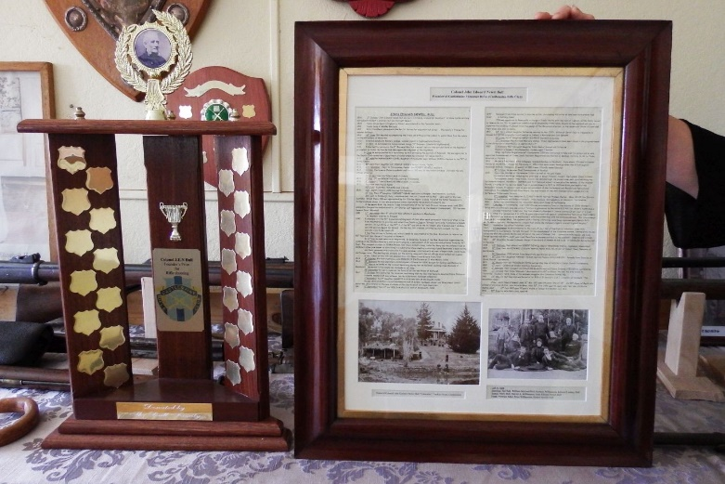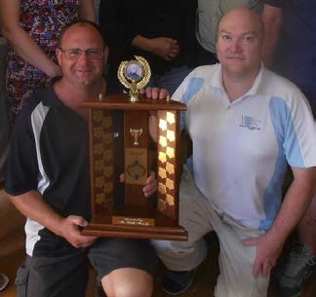

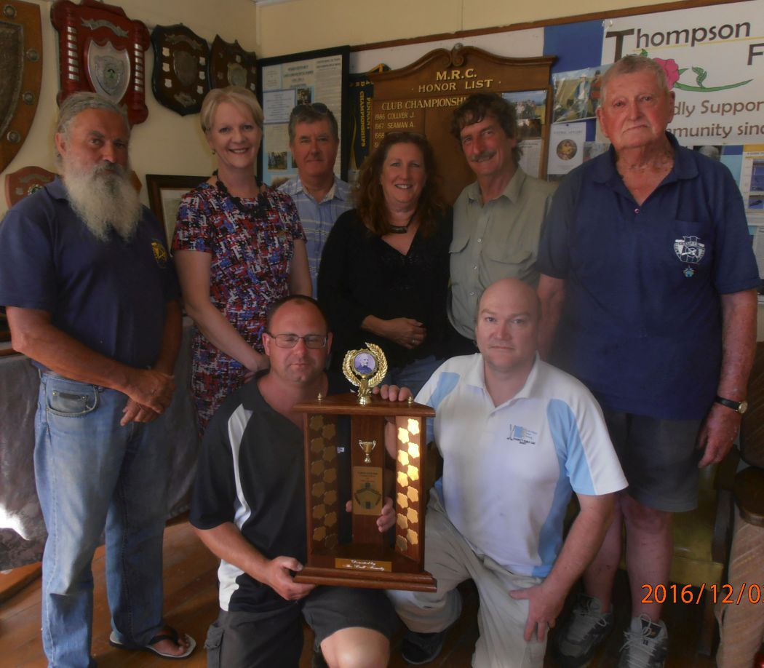

Club Patron, Maree Edwards M.L.A. for Bendigo West once again attended and was delighted to make the presentations. Maree (second from left) is pictured here with the winners, club officials and Col Bull’s descendants.

**To commemorate the day, the occasion, and in appreciation of the involvement of Colonel Bull’s descendants, the Club put on a superb display of memorabilia related to Colonel Bull, ranging from photos, trophies, awards and even a flintlock rifle that came to Australia in 1842 with Colonel Bull and 30 rank and file of the 99th Lanarkshire Regiment of Foot that he commanded.** (Photos at bottom of page)

This was really a remarkable occasion with Colonel Bull’s family, visitors and club members having a great day. It is a great honour to have our Club

connected to such an eminent historically important family s that of Colonel Bull.

The Castlemaine Rifle Club has always endeavoured to retain its long history and to be able to celebrate with direct descendants of our forefather is a uniquely special, awe-inspiring occurrence that the club, and Cheryl and Paul Looby will ensure continues to happen.

Our special thanks go out to all of the Bull family for their instrumentation and promise of longevity of this very special trophy.

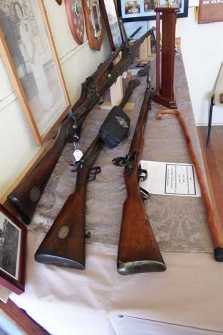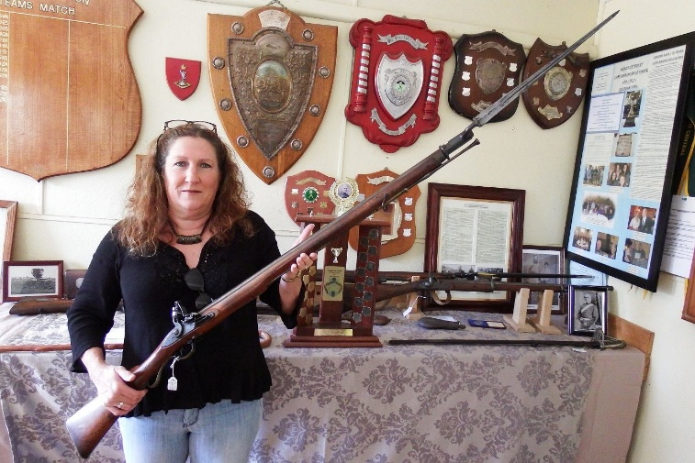

Col Bull’s great-great granddaughter Cheryl Looby

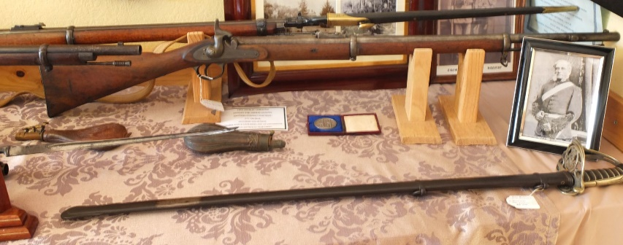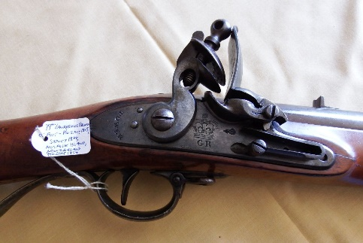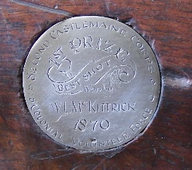 Inscribed: 1st Prize Best Shot won by W McKittrick 1870. 2nd Castlemaine Colonial Volunteer Force